Driving the SiPM Power Board

Contents

List of Figures 1

List of Tables 1

Introduction: 2

SiPM Telemetry Power Board 2

The Cold TPC SiPM Power Board 5

Harnessing 7

Telemetry Harness 9

Setting the High Voltage Level 10

High Voltage Current Monitor 11

List of Figures

Figure 1: Telemetry Power Board 2

Figure 2: Phoenix Header 3

Figure 3: +5V Power LED Indicator (SiPM Telem Board) 4

Figure 4: SiPM Power Board 5

Figure 5: ICD for Telemetry Power Board to SiPM Power Board 5

Figure 6: J3 Connector on SiPM Power Board 6

Figure 7: Power Harnessing 7

Figure 8: Power Harness Instructions (W1) 7

Figure 9: W2 Harness Description 8

Figure 10: Telemetry Harness for SiPM Power Board 9

# List of Tables

Table 1: J1 Connector on Telem Power Board 2

Table 2: J2 - J7 Connector on Telem Power Board 3

Table 3: J3 Connector on SiPM Power Board 6

# Introduction:

There are a few ways that you can achieve powering the SiPM power board, this document will describe how it is meant to be used in flight. This document will describe the boards and their interconnect with some guidance on how to make the harnessing. It is important to follow the safe-to-mate procedures before applying power. You’ll want to make sure you don’t have any shorts on the boards, and then ensure that the harnessing is made properly.

# SiPM Telemetry Power Board

Per discussions during Friday’s meetings, there will be a total of 6 SiPM power boards, the telemetry power board has been modified to serve this goal:

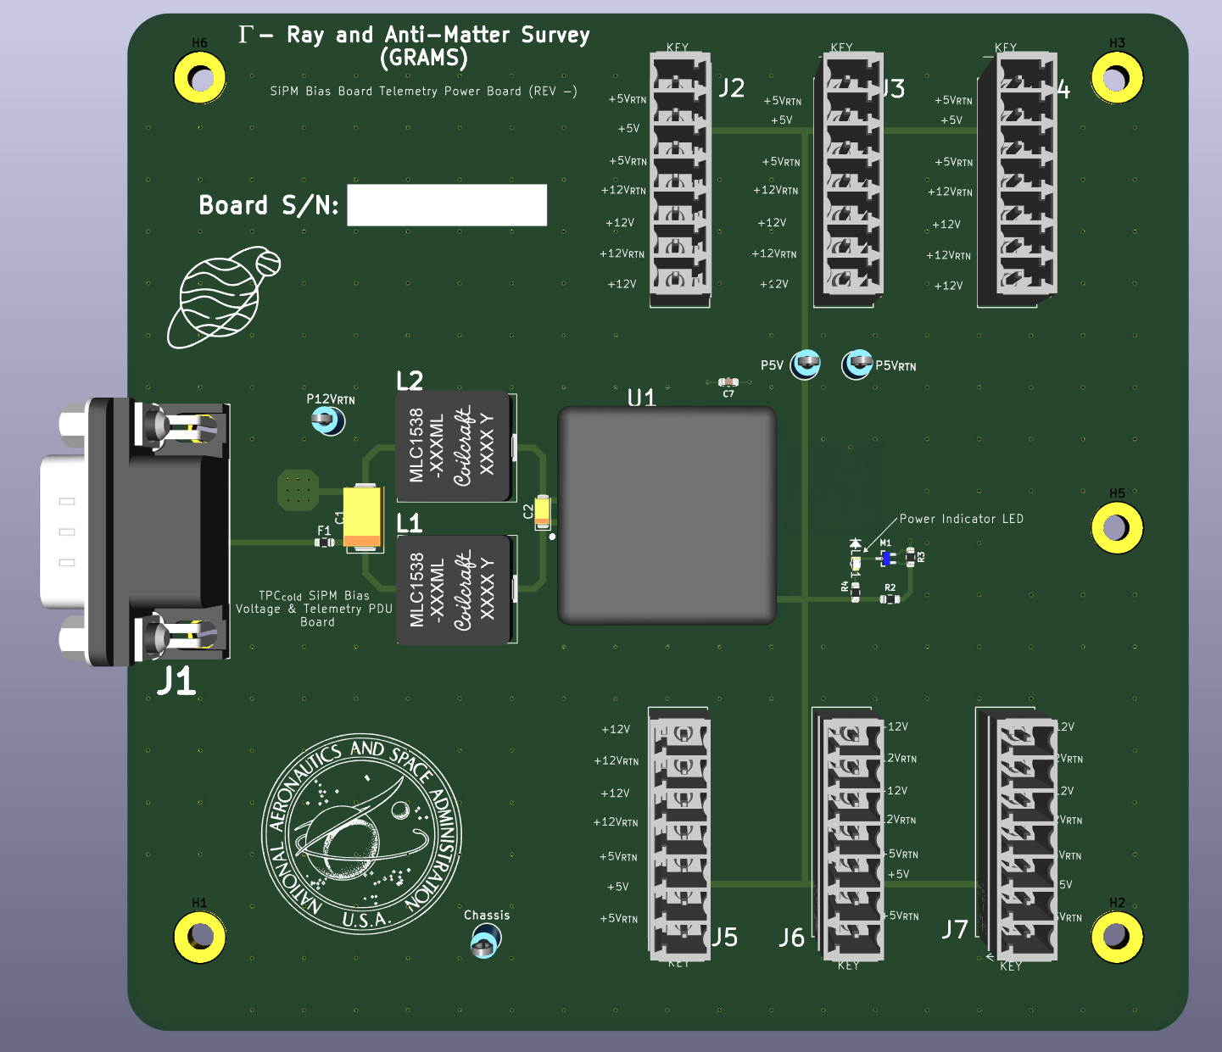

Figure 1: Telemetry Power Board

The J1 connector receives input power of +12V, while J2 – J7 provide +5 and +12V to the SiPM boards. The Interface Control Documentation for this board is in the table on the next page:

|  |  |  |  |  |  |
| --- | --- | --- | --- | --- | --- |
| Connector Part Number | Manufacturer | Connector Description | Connector Designator | Pin Designator | Signal Description |
|  |
| 618009231221 | Wurth Electronik | Male 9-Pin D-Sub | J1 | 1 | +12V Return |  |
| 2 | +12V Return |  |
| 3 | No Connect |  |
| 4 | +12V Return |  |
| 5 | +12V Return |  |
| 6 | +12V Input |  |
| 7 | +12V Input |  |
| 8 | +12V Input |  |
| 9 | +12V Input |  |

Table 1: J1 Connector on Telem Power Board

|  |  |  |  |  |  |
| --- | --- | --- | --- | --- | --- |
| Connector Part Number | Manufacturer | Connector Description | Connector Designator | Pin Designator | Signal Description |
|  |
| 1803471 | Phoenix Contact | Terminal Block Header | J2 - J7 | 1 | +5V Return |  |
| 2 | +5V Input |  |
| 3 | +5V Return |  |
| 4 | +12V Return |  |
| 5 | +12V Input |  |
| 6 | +12V Return |  |
| 7 | +12V Input |  |

Table 2: J2 - J7 Connector on Telem Power Board

The Phoenix Connector terminal blocks have keys associated with the way the connector mates:

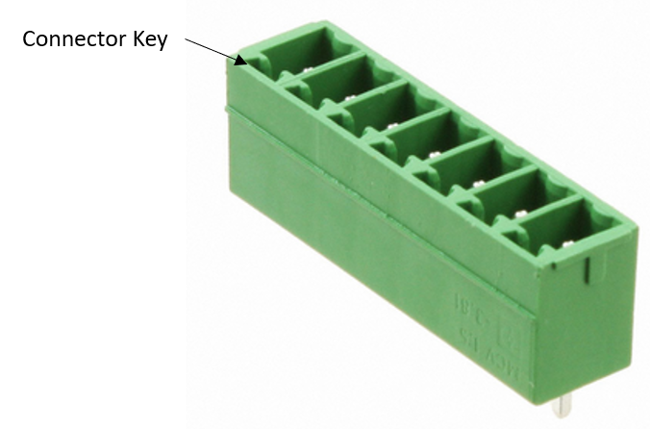

Figure 2: Phoenix Header

The pinouts are also printed on the Silk-Screen with the direction of the key called out on the board. There are also several probe points added to the design, these provide a +12V Return, Chassis, and +5V and +5V Return for ease of probing in the event you need to.

The LED on the board will indicate if the +5V is being generated.

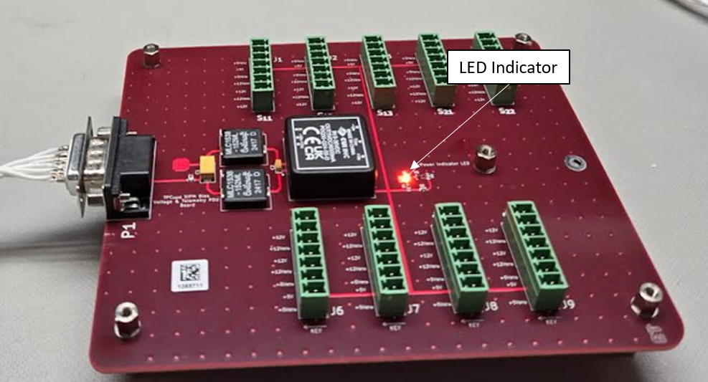

Figure 3: +5V Power LED Indicator (SiPM Telem Board)

The above board is the prototype that was made when we were targeting 9 SiPM boards, the GERBERs included with this document are for a board servicing 6 boards. (See Figure 1).

# The Cold TPC SiPM Power Board

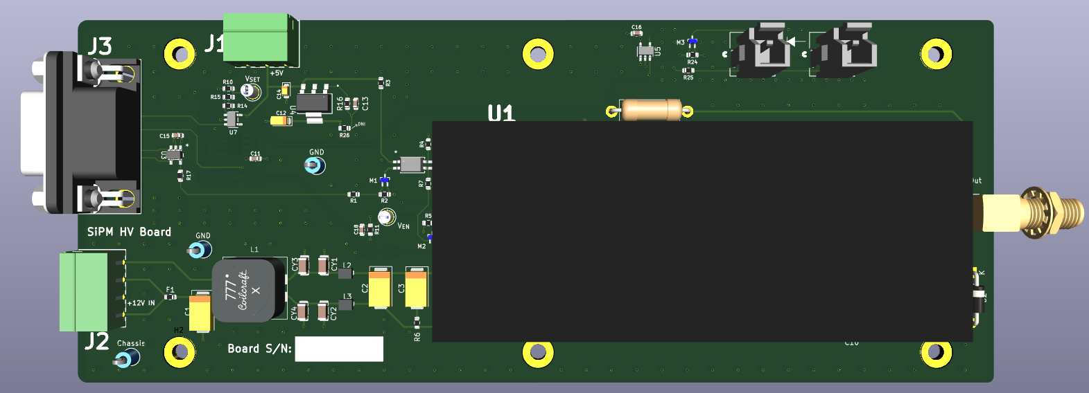

Figure 4: SiPM Power Board

Some updates have been made to this design to answer issues found in the prototype.

Both J1 and J2 on this board are receiving the +5 and +12V from the Telemetry power board described above. The figure below describes the connections:

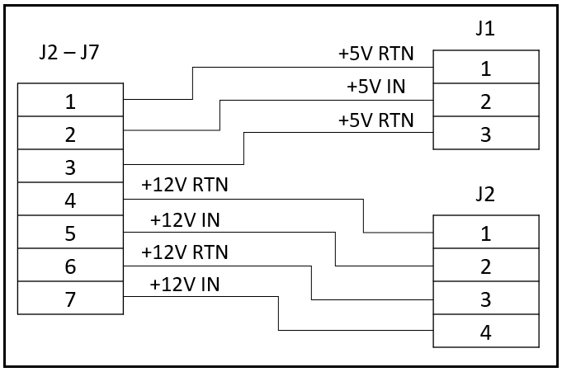

Figure 5: ICD for Telemetry Power Board to SiPM Power Board

*Always make sure to inspect with an Ohm Meter before applying power!!!*

The connectors all have silk screen identifiers with markings on which connectors carry power.

The J3 connector on the SiPM Power Board carries all of the command and control as well as telemetry. The figure below describes this connector:

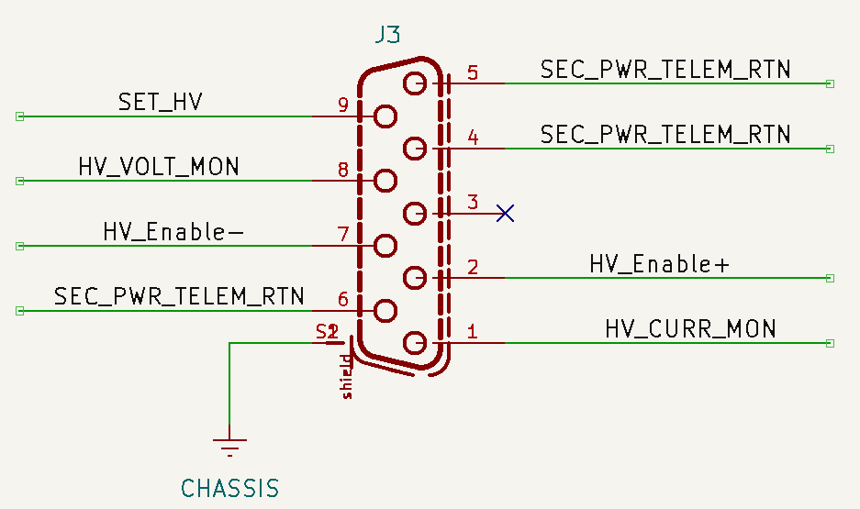

Figure 6: J3 Connector on SiPM Power Board

|  |  |  |  |  |  |
| --- | --- | --- | --- | --- | --- |
| Connector Part Number | Manufacturer | Connector Description | Connector Designator | Pin Designator | Signal Description |
|  |
| 618009231121 | Wurth Electronik | Male 9-Socketed D-Sub | J1 | 1 | HV Current Mon |  |
| 2 | HV Enable + |  |
| 3 | No Connect |  |
| 4 | Return Line |  |
| 5 | Return Line |  |
| 6 | Return Line |  |
| 7 | HV Enable - |  |
| 8 | HV Voltage Mon |  |
| 9 | Set HV Level |  |

Table 3: J3 Connector on SiPM Power Board

# Harnessing

To ensure you aren’t introducing any noise to the circuitry, you’ll want to pay attention to how the harnessing is made. The figure below is only addressing the harnesses carrying power.

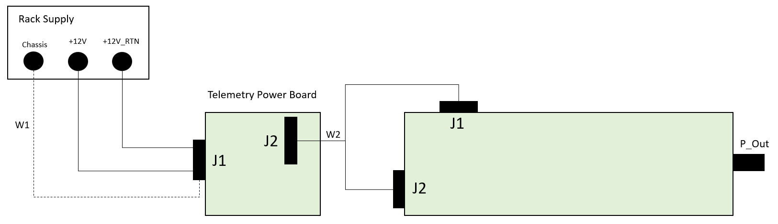

Figure 7: Power Harnessing

The W1 harness will feed power into the Telemetry Power Board, the chassis connection is not essential for a simple power test. I would recommend this as the sub-system tests become more complex.

To adequately connect the chassis grounds, you’ll need to procure the back-shell assembly for the D-Sub connector going into J1. This part number is called out in the parts list. Please see the figure below describing the harnessing:

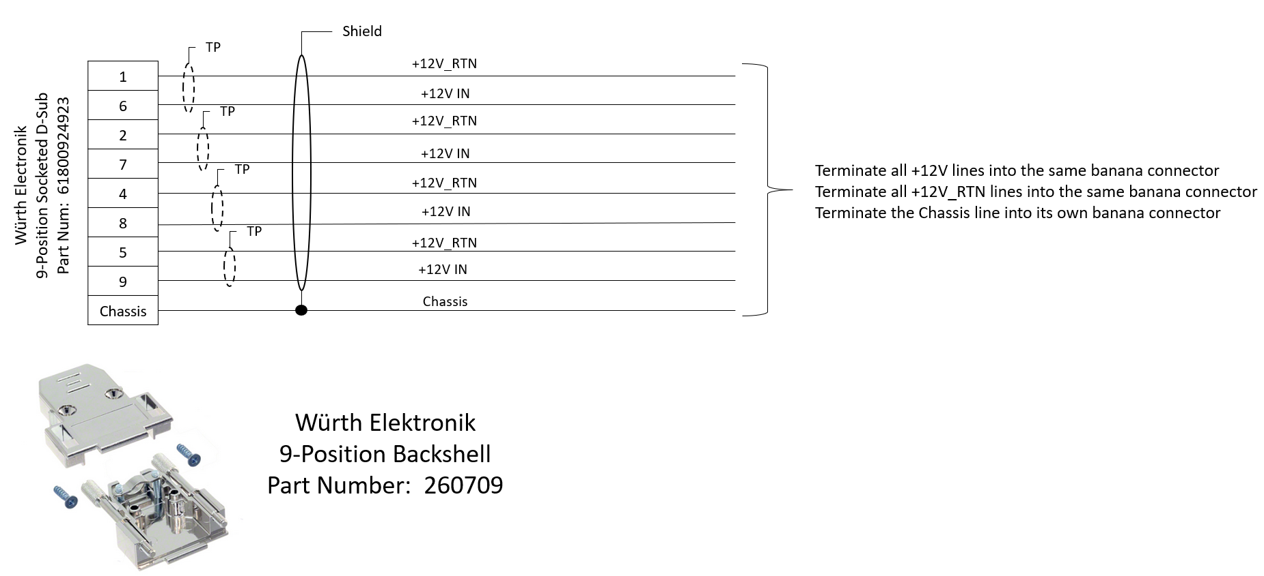

Figure 8: Power Harness Instructions (W1)

The W2 harness is described in the figure below:

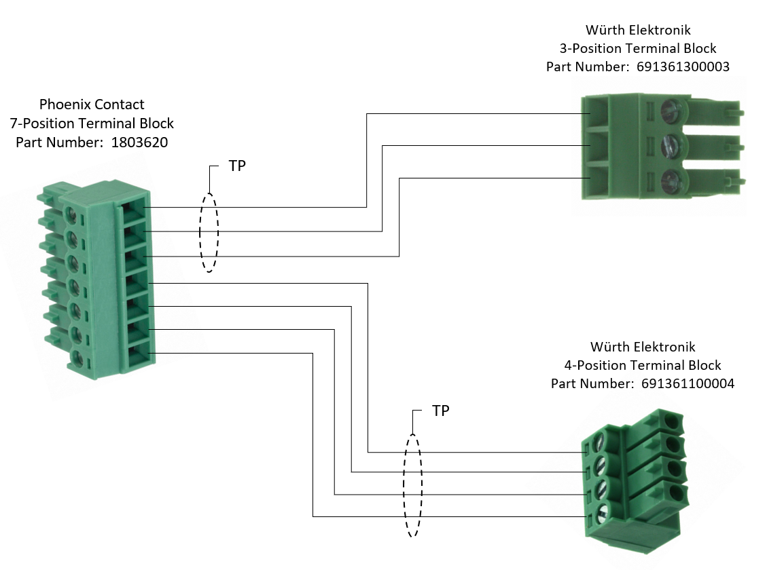

Figure 9: W2 Harness Description

## Telemetry Harness

The J3 harness on the SiPM Power Board is carrying the telemetry and enable signals.

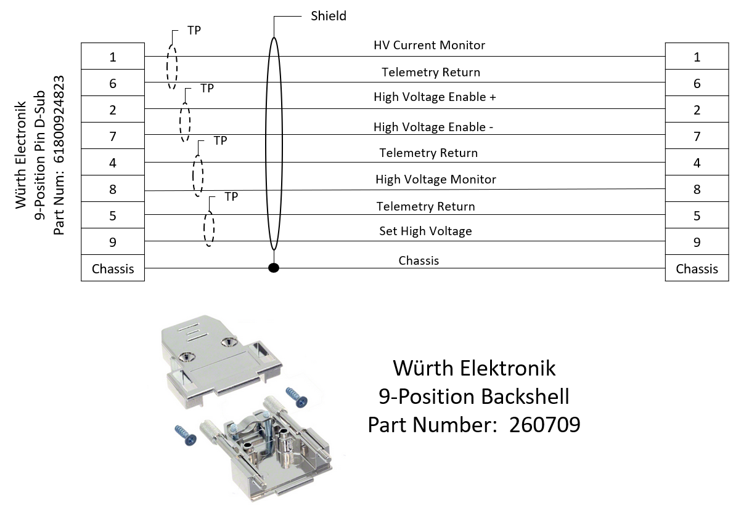

Figure 10: Telemetry Harness for SiPM Power Board

You can choose to run these signals out to a breadboard for ease of monitoring; however, you’ll need to determine how to handle the enable/disable feature. Currently, the differential signal being received for the enable/disable is going into the *Texas Instruments SN65LVDT2DBVT* part. To adequately drive this part, you’ll need to acquire the *SN65LVDS1* part. Be very cognizant of the grounding between your control board and the SiPM Power Board, it is easy to harm the LVDS drivers if this is not scrutinized.

Or remove R5, R17, and M2 from the board, and drive the enable probe point manually.

# Setting the High Voltage Level

The high voltage level is set via pin 9 on the J3 connector. Setting this pin from 0 to 5 volts will cause the converter to provide 0V to 65V, in a linear fashion.

# High Voltage Current Monitor

The output voltage is approximately 1mA per Volt. Meaning, if you read 1V at the output, you are providing approximately 1mA of current. I have included a voltage divider on this going to the OPAMP readout so we don’t over power the input of the opamps. This is divided down by a factor of 10, if supplying 20mA, you should read 2V here.